Login/register – DESIGN 1

Logo goes here

Blue header

All font is Arial unless otherwise stated.

Sizes of mock ups are approximately the same ratio as actual screen size of webpages when viewed in Google Chrome.

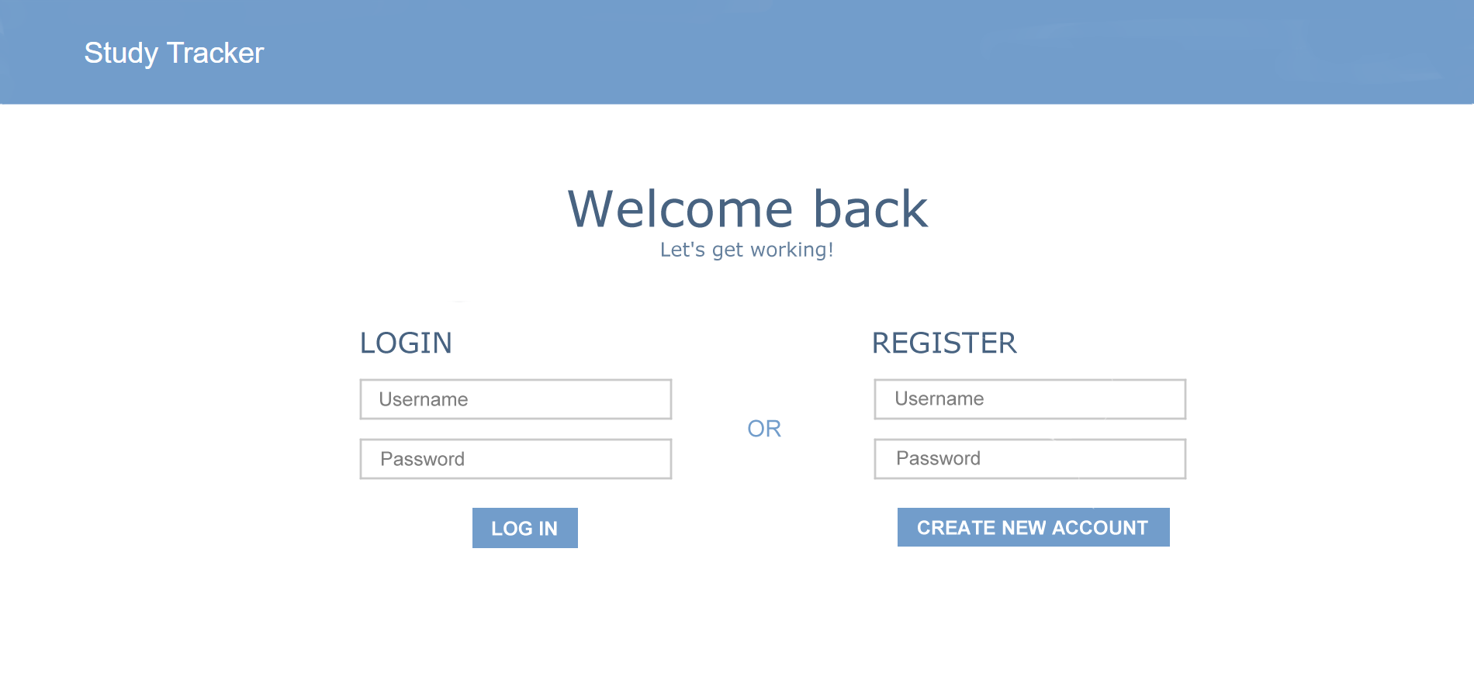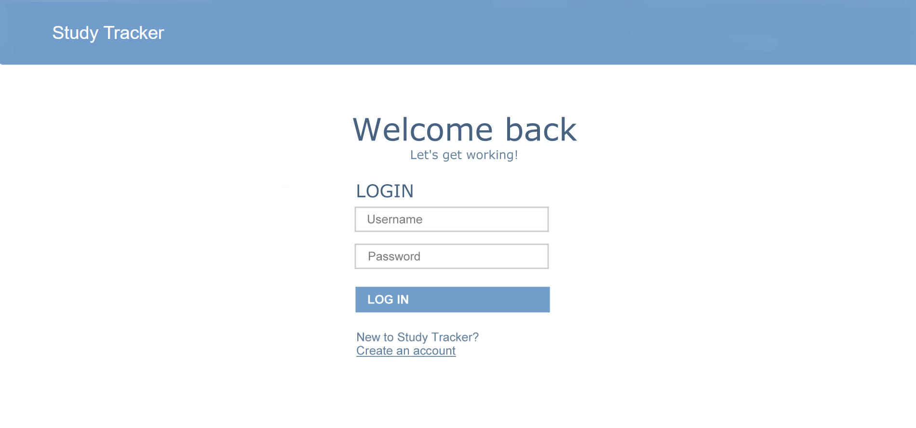

Button redirects users to the main page

White, bolded, medium sized text on a blue button

Navy blue, medium sized, underlined link

Link redirects user to register page

Light grey, medium sized

Text input for password is hidden

Text inputs for username and password, required

Buttons are centred, redirects to main page

Dark navy blue, medium-large sized

Navy blue, medium sized

Dark navy blue, large sized

Same functions and formatting as the login page unless otherwise stated

Button creates a new user account and redirects users to the main page

Light blue, medium sized

Same functions and formatting as design 1 unless otherwise stated

Login/register page – DESIGN 2

Redirects user to login page

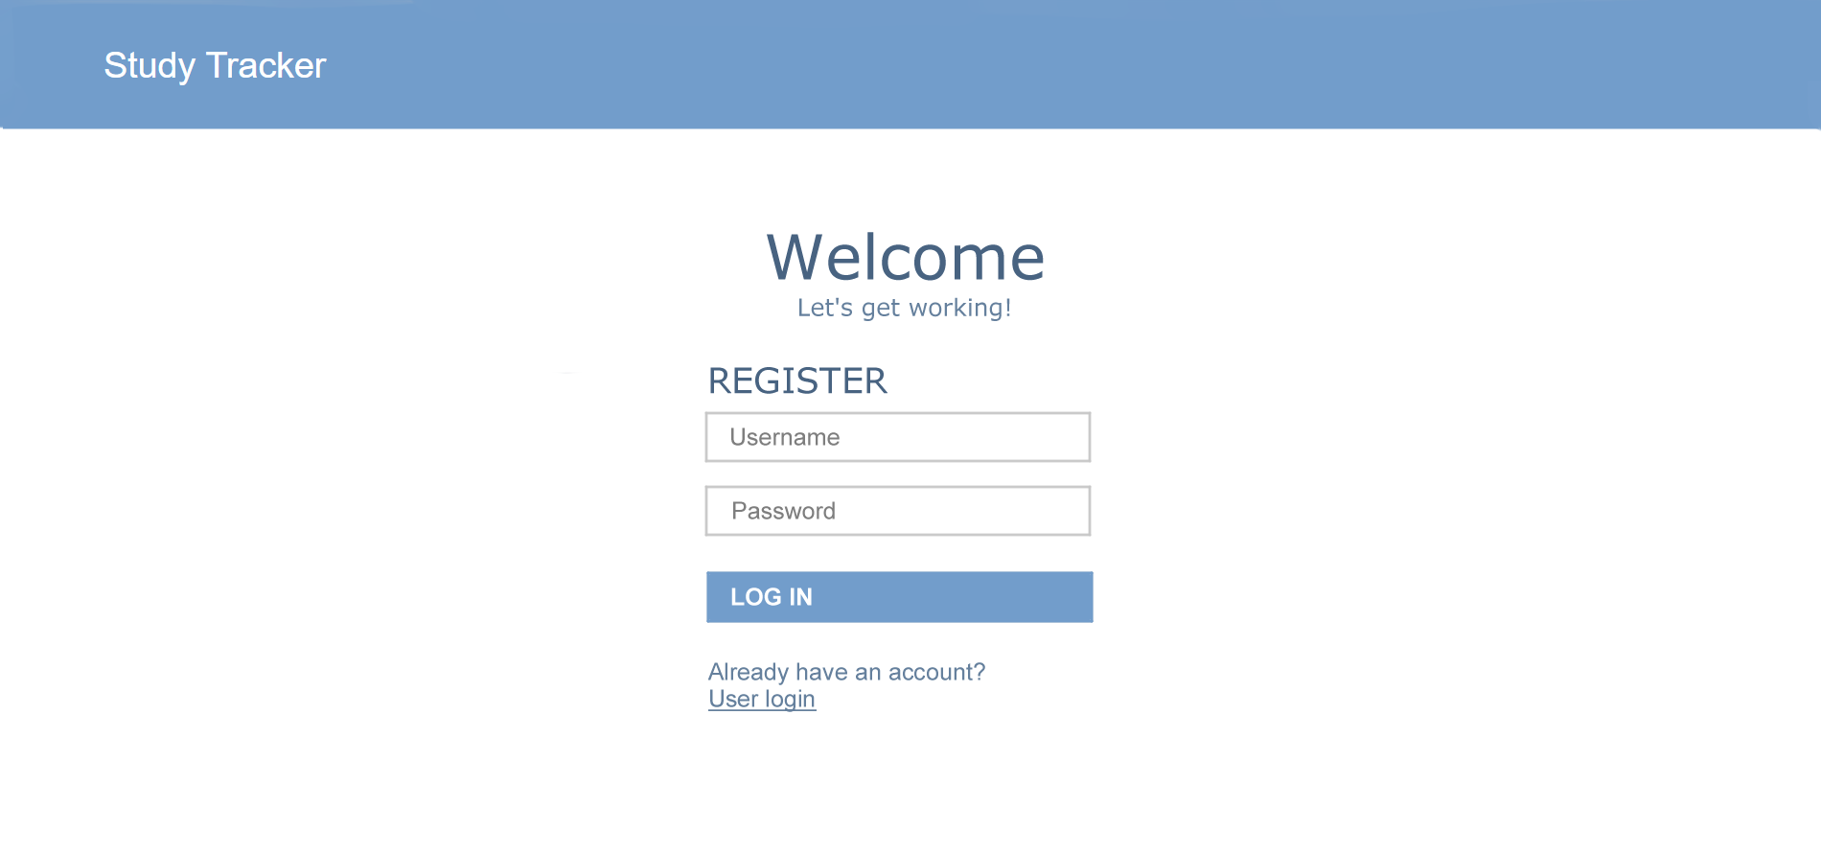

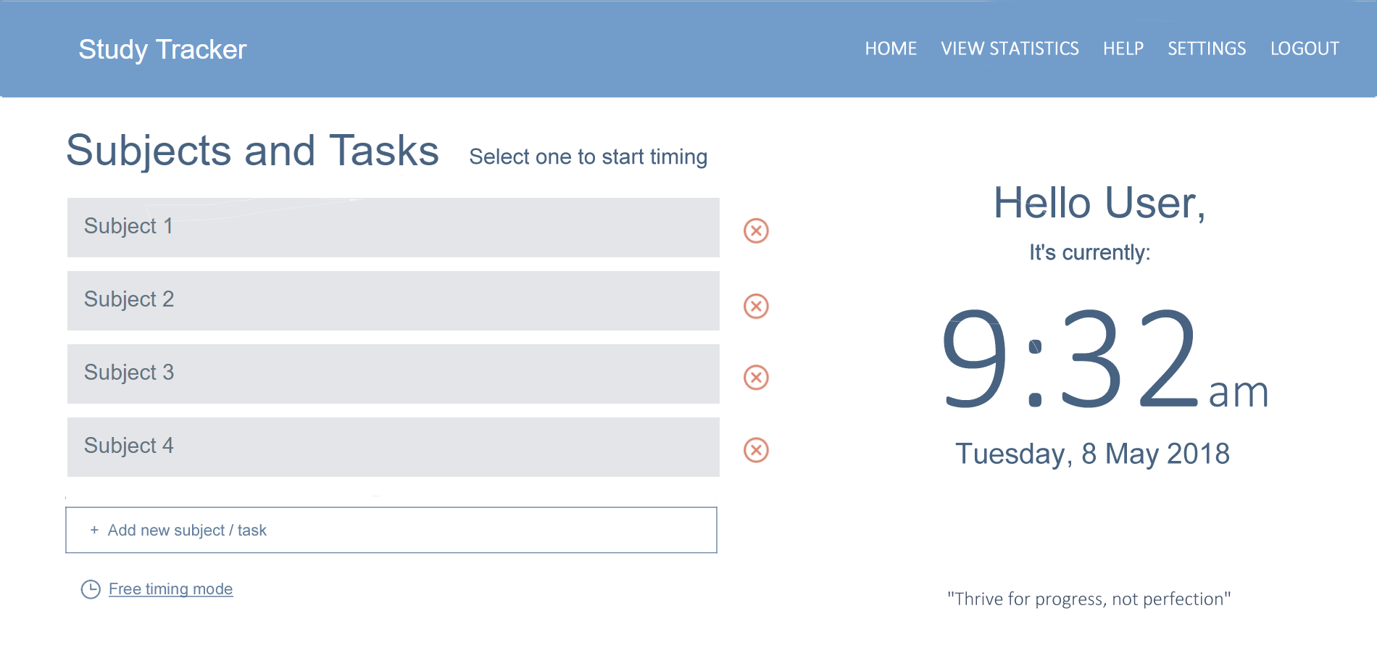

Dark navy blue. Calibri Light, extra-large sized for clock and Arial, medium-large sized for date

Functional clock and date

Redirects users to the relevant pages

Text input that adds new subjects or tasks to the list

Dark navy blue, medium sized

Light grey buttons that link to the timer page

Calibri Light, white, medium sized

Blue header

User’s name is outputted here

Blue-grey, medium sized

Logo goes here

Buttons to delete a subject/task

Dark navy blue, large sized

Main page – DESIGN 1

Link that redirects user to the timer page but doesn’t record the length of time for a specific subject/task. Time recorded is added to the total time spent working instead

Navy blue, small sized, same width as the list of subjects/ tasks

Quote

Calibri Light, dark navy blue, small sized

Navy blue, small sized, underlined

Slim blue-black header

Same functions and formatting as main page - design 1 unless otherwise stated

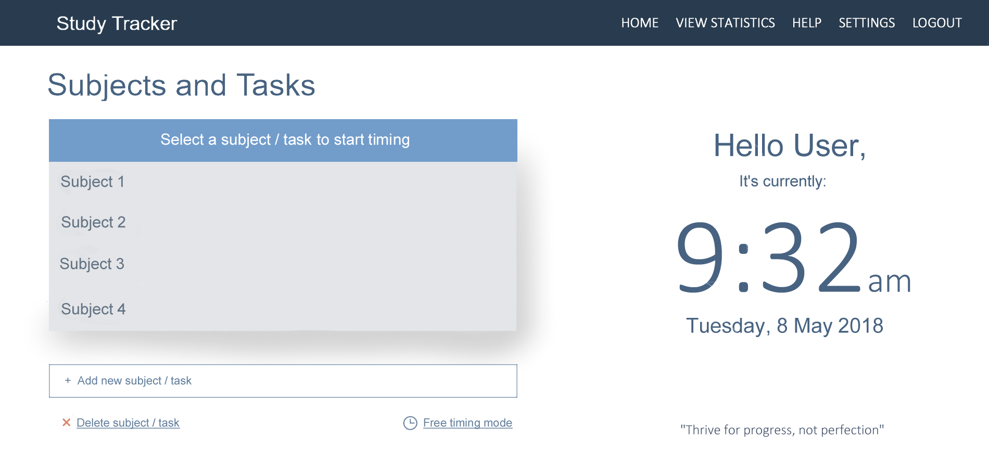

Blue box containing white text, medium sized

Main page – DESIGN 2

Dropdown box containing list of subjects/ tasks.

Can only be accessed when user hovers above the blue box

Redirects user to settings – manage subjects/tasks page

Grey shadow

Light grey dropdown list

Navy blue, small sized, underlined

Blue-black, large sized

Same functions and formatting as design 1 unless otherwise stated

Red gradient header

Main page – DESIGN 3

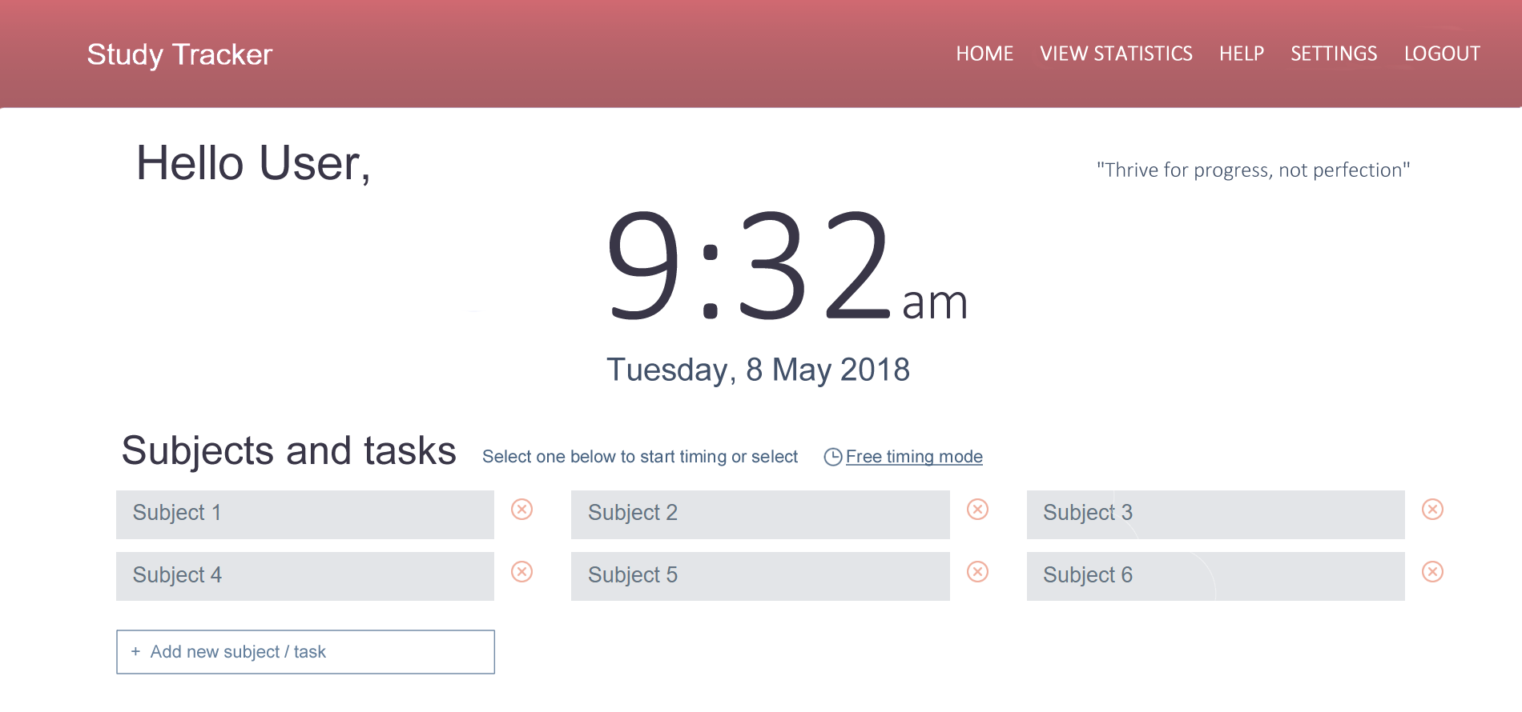

Dark navy blue, small sized

Link that redirects user to the timer page but doesn’t record the length of time for a specific subject/task.

Blue-grey, small-medium sized

Buttons that link to the timer page

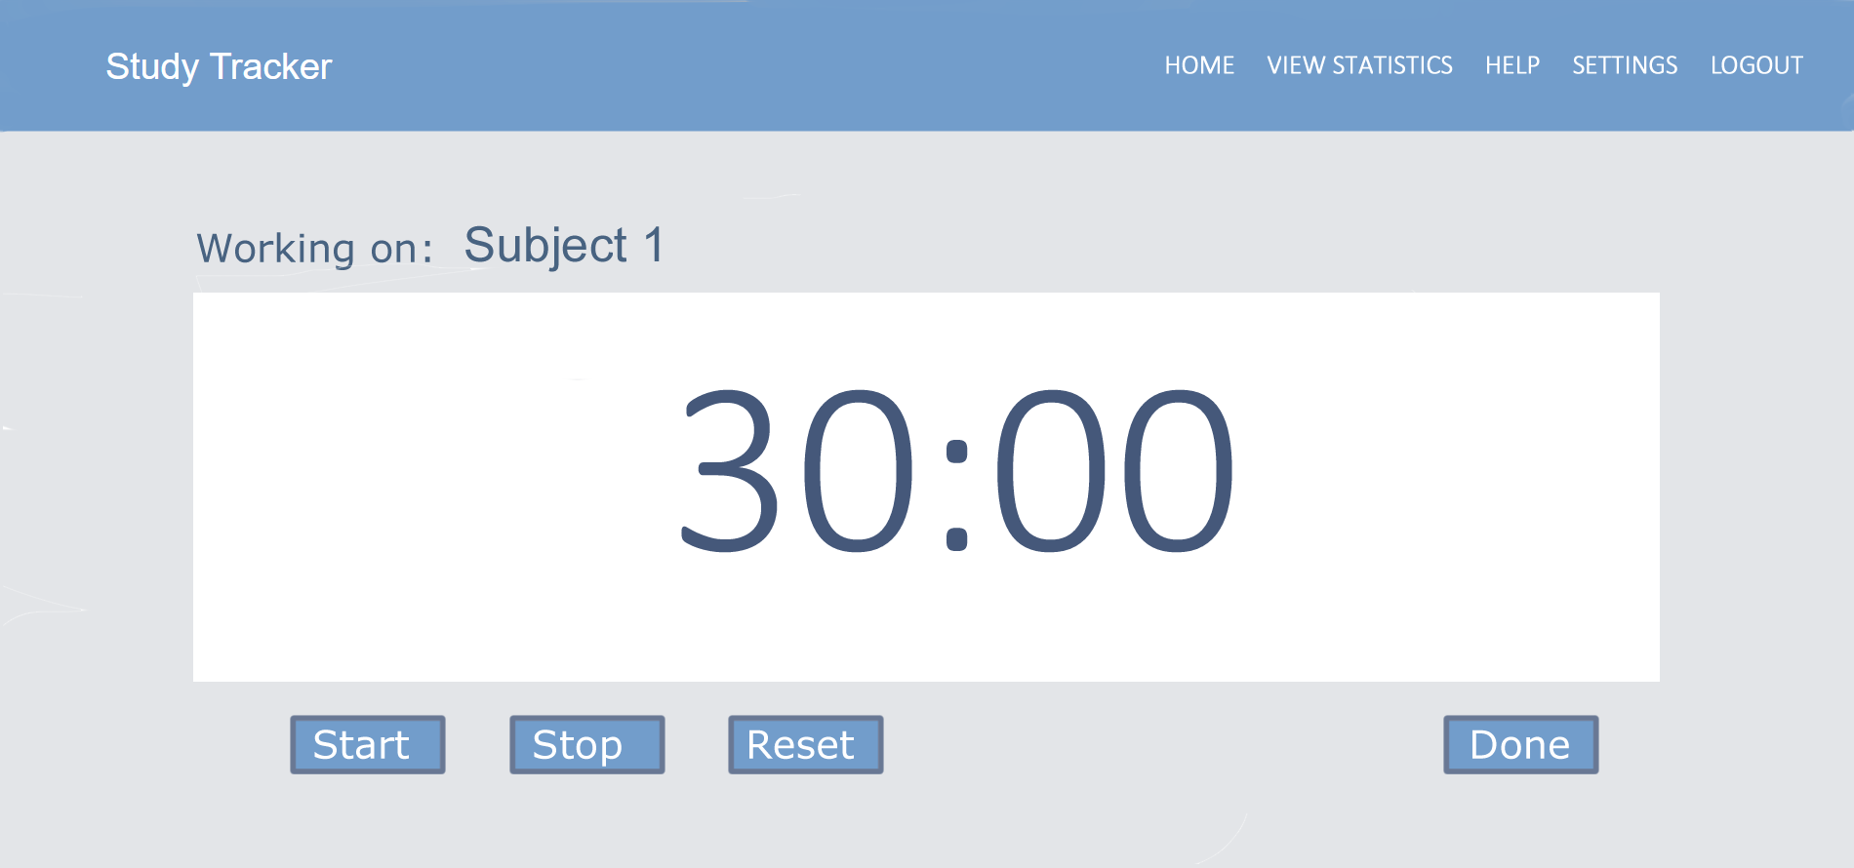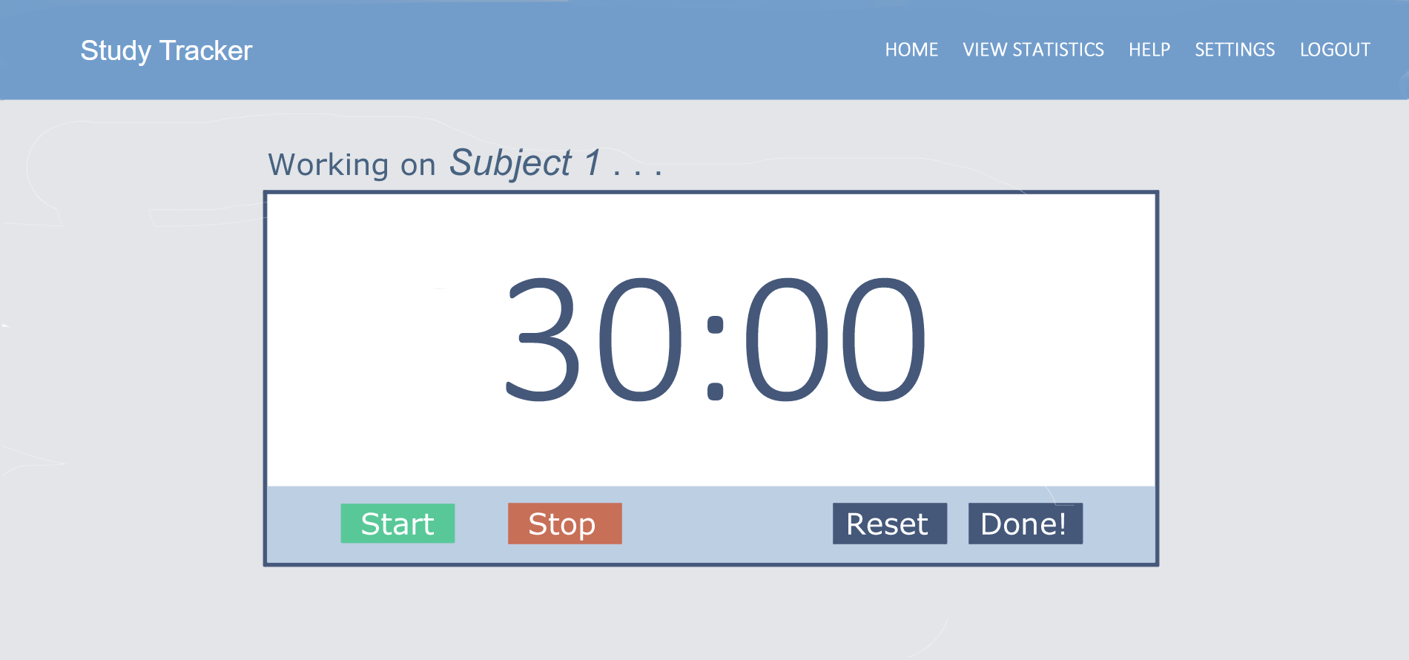

Dark navy blue buttons containing white, medium sized text

Red button containing white, medium sized text

Green button containing white, medium sized text

Light blue section of white box containing buttons

White box with thick dark navy blue border

Dark navy blue, medium-large sized, italicized

Selected subject/task name is outputted here

Same functions and formatting as timer page - design 1 unless otherwise stated

Timer page – DESIGN 2

Pauses the timer and resets it back to default value

Redirects user to the timer done page for user confirmation

Pauses the timer

Starts the timer

Blue buttons with a navy blue border containing white, medium sized text

Functional timer

Dark navy blue, extra-large sized

White box

Dark navy blue, medium sized

Dark navy blue, medium-large sized

Blue header

Selected subject/task name is outputted here

Light grey background

Logo goes here

Calibri Light, white, medium sized

Timer page – DESIGN 1

**Some other mock ups of solution that do not have alternative designs**

Timer length is outputted here

Same functions and formatting as the final selected timer design unless otherwise stated

Selected subject/task name is outputted here

Dark navy blue, medium sized, italicized

Timer done page

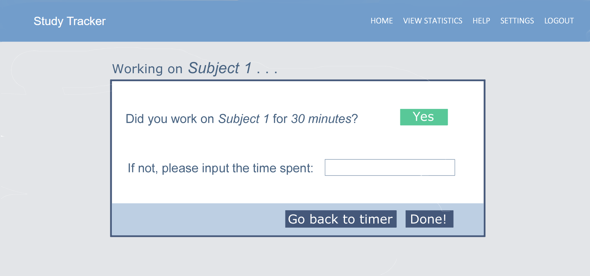

Redirects to timer page

Redirects to main page

Select dropdown list containing numbers in intervals of 5

Saves value specified

Green button containing white, medium sized text

Dark navy blue, medium sized

Dark navy blue buttons containing white, medium sized text

Calibri Light, white, small-medium sized

Blue header

Logo goes here

Report (view statistics) page

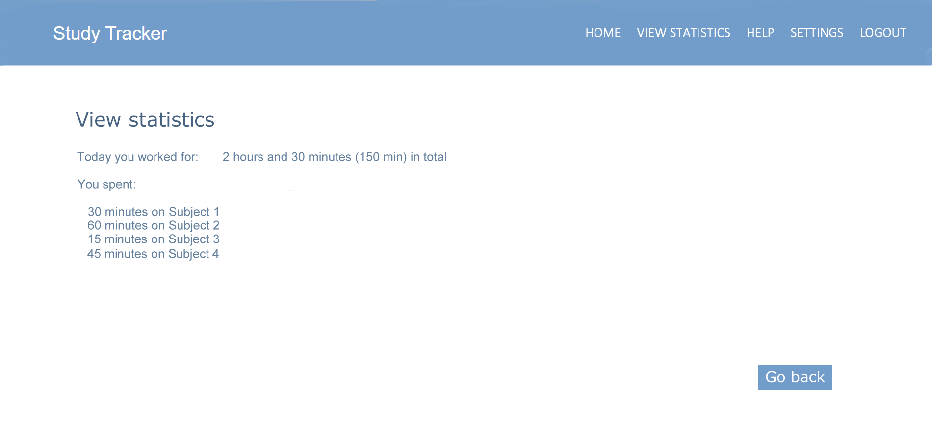

Note: output used in final solution may vary – these are just sample statistics

Navy blue, medium sized

Dark navy blue, medium-large sized

Calculated statistics about the time spent

Redirects user to main page

Blue button containing white, medium sized text

Same functions and formatting as report (view statistics) page unless otherwise stated

Help page

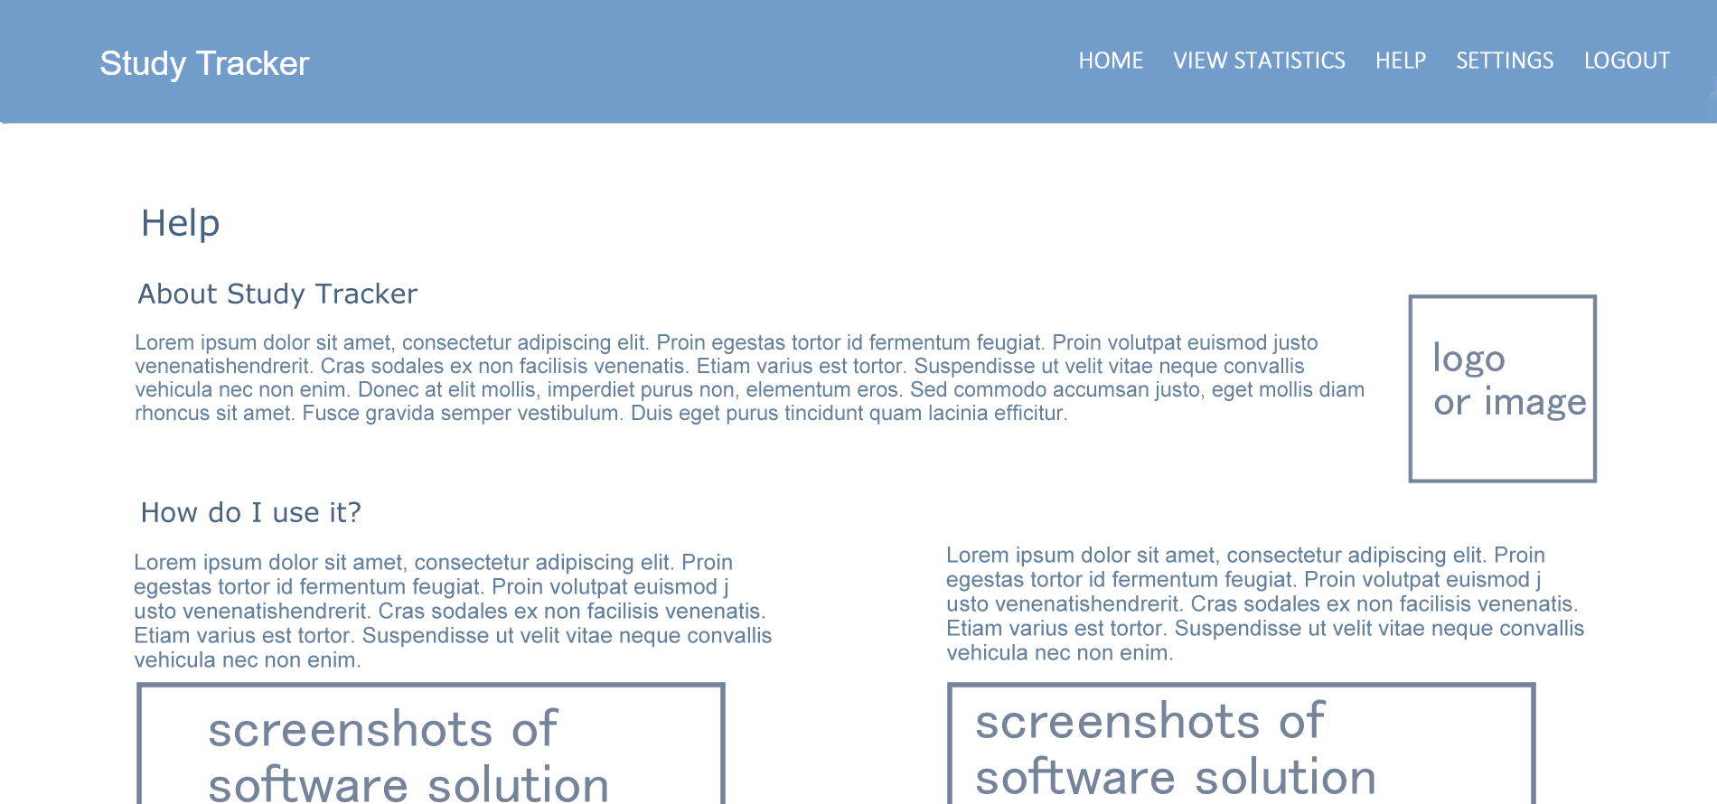

Image of the software’s logo or another relevant image (a timer, books, students etc.)

Note: output and layout used in final solution may vary depending on the final features implemented

Navy blue, medium sized (but slightly smaller than subheadings size)

Dark navy blue, medium sized

Dark navy blue, medium-large sized

Text

Images have a thick navy blue border

Users scroll down for more info

Subheadings

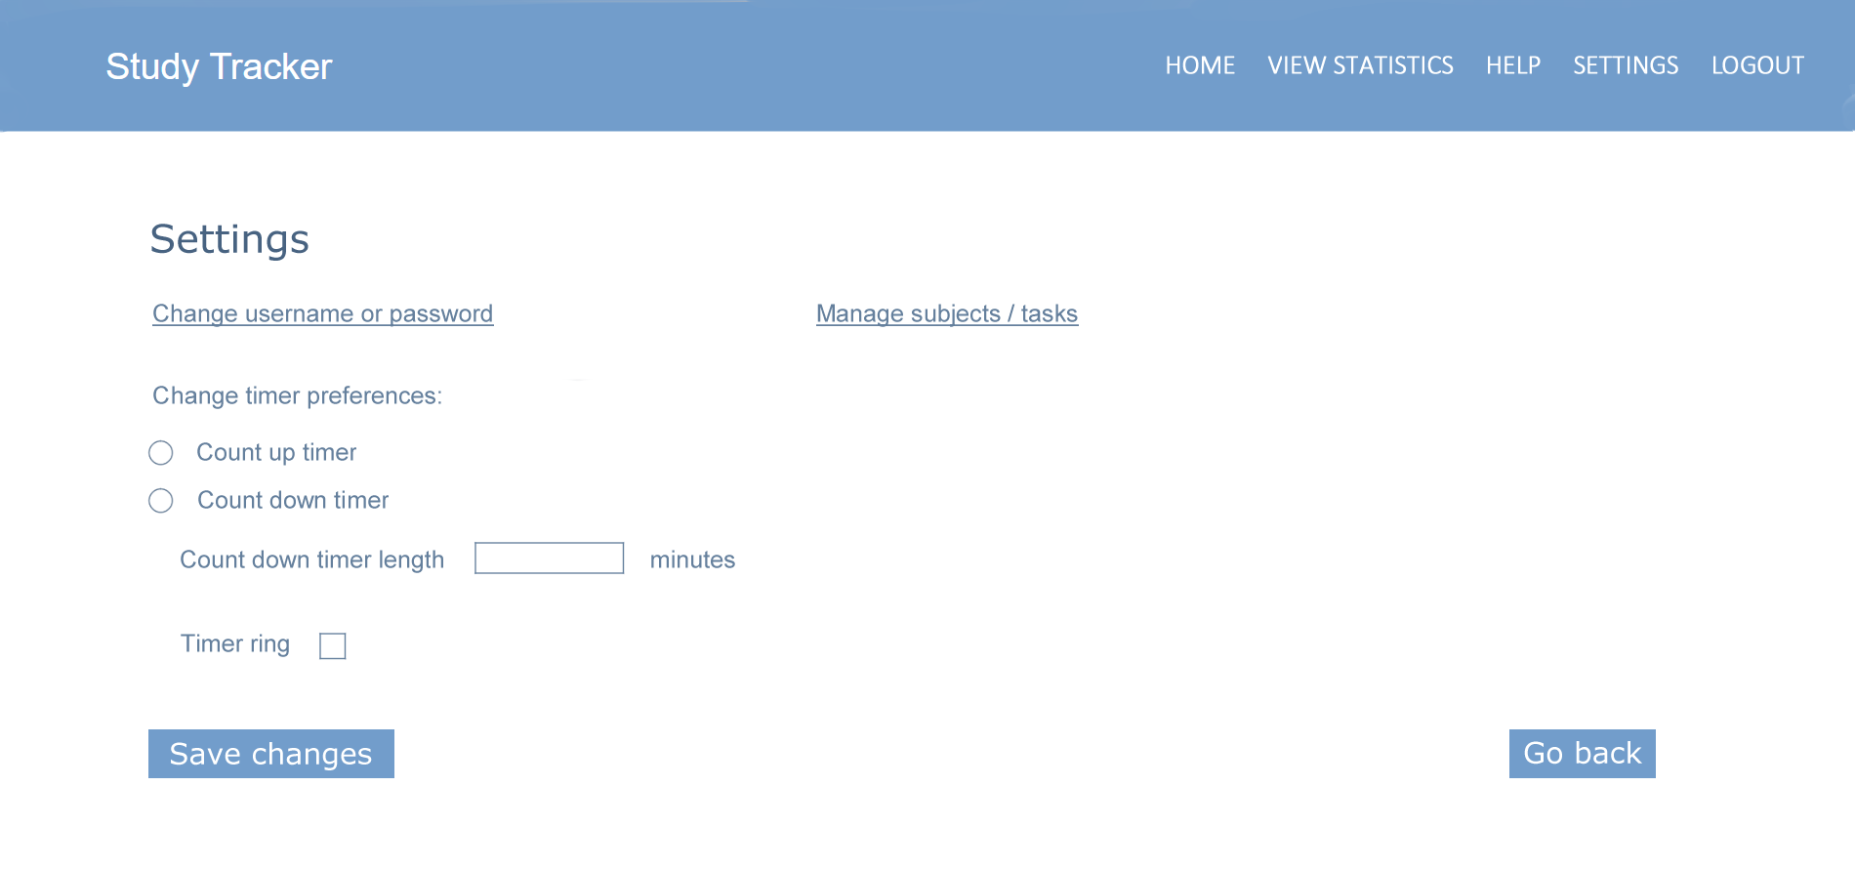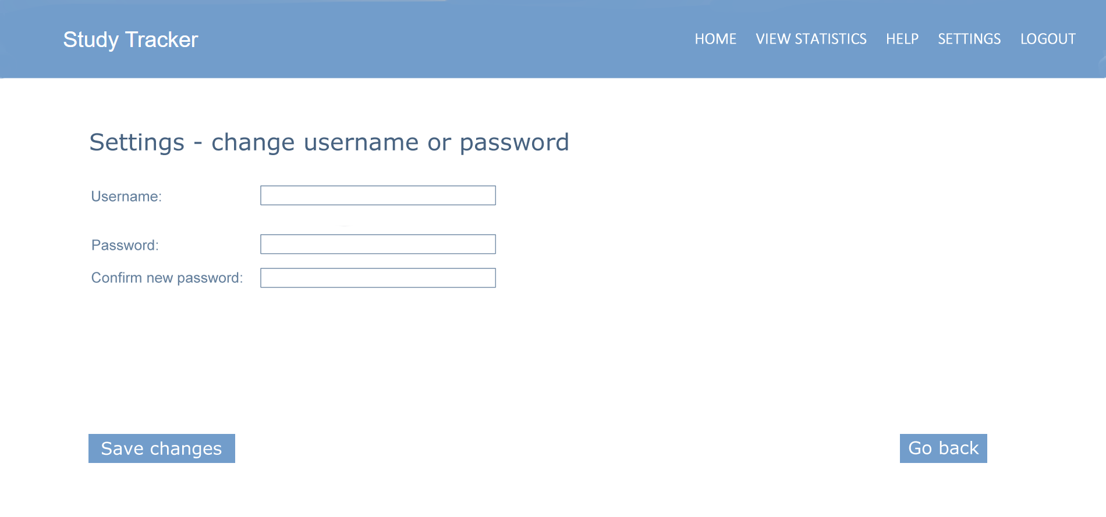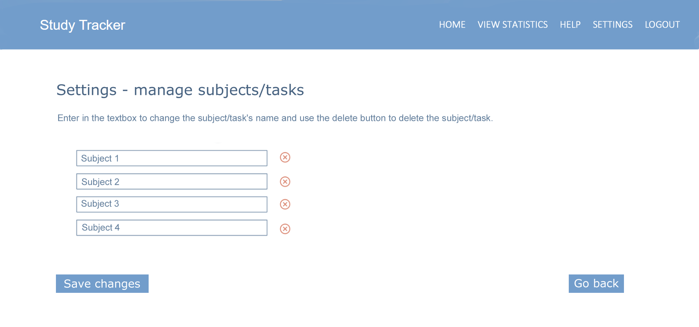

Links that redirect user to another settings page (manage account and manage subjects/tasks page) to make changes

Navy blue, medium sized text, underlined

Same functions and formatting as report (view statistics) page unless otherwise stated

Note: output and layout used in final solution may vary depending on the final features implemented

Blue button containing white, medium sized text

Applies changes for the user

Radio buttons to choose between options

Select dropdown list containing numbers in intervals of 5

Checkbox to toggle on/off

Dark navy blue, medium-large sized

Settings page – manage account

Redirects user back to settings page

Settings page – manage account

Text inputs

Text inputs for password is hidden

Same functions and formatting as settings page unless otherwise stated

Same functions and formatting as settings – manage account page unless otherwise stated

Buttons to delete subject/task

Text inputs that contain the name of the subject/task

Settings page – manage subjects/tasks